**create a new react app**

**Step 1:**

Install globally “create-react-app” with npm



**Step 2:**

Change current path to the path that you want to store the new project



**Step 3:**

Create new project

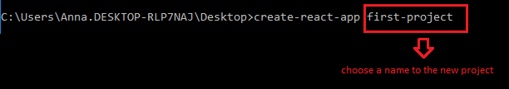

**Step 4:**

Change current path to the new project’s path



**Step 5:**

Run the project with the “npm run” command:

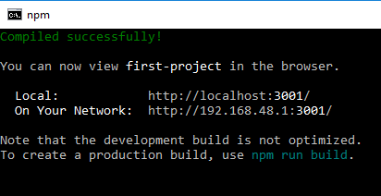

**Step 6:**

Get the following result in the browser:

